MANAGE WORKPLACE SAFETY AND HEALTH IN CONSTRUCTION SITES

Company Name: ________________________________________________________________________________

Contact Person: ____________________________________ H/P: ____________________________________

Tel: ________________ Fax: _________________ Email: ______________________________________________

Address: ______________________________________________________________________________________

No. | NRIC/FIN/WP No: | Full Name | Nationality | Mobile No | Email ID
1.
2.
3.
4.
5.
Course Fees: $350/-per participant (Excluding 9% GST)
Total course fee: $___________Payment Mode: Cash Cheque Cheque No. ______________ (payable to EFG Training Services Private Ltd)

- The company reserves the right to revise the course fee without prior notice, to cancel or postpone the course due to unforeseen circumstances
- Replacement and Withdrawal
- 90% refund will be made if the notice of withdrawal in writing is received by EFG at one week before the course commencement date. If such notice is received by EFG less than one week but more than three working days before the course commencement date, 75% refund will be made. No refund will be given if EFG received the notice of withdrawal 3 working days before the course commencement date. Replacement of participant is allowed if the request is made before the commencement of the course
__________________ __________________________
Name: Signature/Date

Company Stamp

MANAGE WORKPLACE SAFETY AND HEALTH IN CONSTRUCTION SITES

Course Overview
This unit equips learners with knowledge and skills in managing workplace safety and health management system, ensuring safety and health measures are put in place in construction activities and other industries.

Who should attend this course?
The occupations that this unit would be relevant to include but not limited to:
Supervisors, Assessors or Managers who are involved in planning / assessment or management of work activities in construction and other industries.

Course Objectives
- Understand the legal obligations of duty holders, including project managers of worksite under the new WSH framework.
- Form the WSH Committee and implement its functions.
- Plan and implement safety programme, system and safe work procedure for construction activities in accordance with WSH (Construction) Regulations.
- Plan and implement an occupational health programme and risk assessment in accordance with general principals and requirements of related WSH Regulations and Guidelines.
- Plan and implement risk management for all construction activities in accordance with general principals and requirements of related WSH Regulations and Guidelines
- Establish the procedures for accident reporting, accident prevention in accordance with general principals and requirements of related WSH Regulations and Guidelines.
- Establish and implement Safety and Health Management System in worksite in accordance with general principals and requirements of related WSH Regulations and Guidelines.
- Plan and participate in safety and health audit and review in worksite in accordance with general principals and requirements of related WSH Regulations and Guidelines.

Pre-Requisites / Assume Skills and Knowledge
The Learner should have at least WSQ ESS Workplace Literacy and Numeracy Level 6 and above or equivalent and the knowledge of the construction industry activities.
Learners must be holding the position of Chairman of Safety Committee, Project Manager, Project Engineer, Superintendent or equivalent post to be eligible to attend this course.

Trainer to Trainee Ratio
1: 20 (Classroom)

Attendance requirements
75%

Assessment
Comprising both Theory and Practical Session
E-Assessment

Medium of Instruction
English

Training Methodology
Slides presentation, sharing of best practice and incident. Hands on practical session.

Passing marks
Learner must achieve 75%

Certifications
Upon successful completion of the course a Statement of Attainment (SOA) will be awarded by SkillsFuture Singapore Agency (SSG). Certificates Cards shall be endorsed by EFG Training Services Private Ltd and issued to participants at the end of course

Course Fees
$350+GST

MANAGE WORKPLACE SAFETY AND HEALTH IN CONSTRUCTION SITES

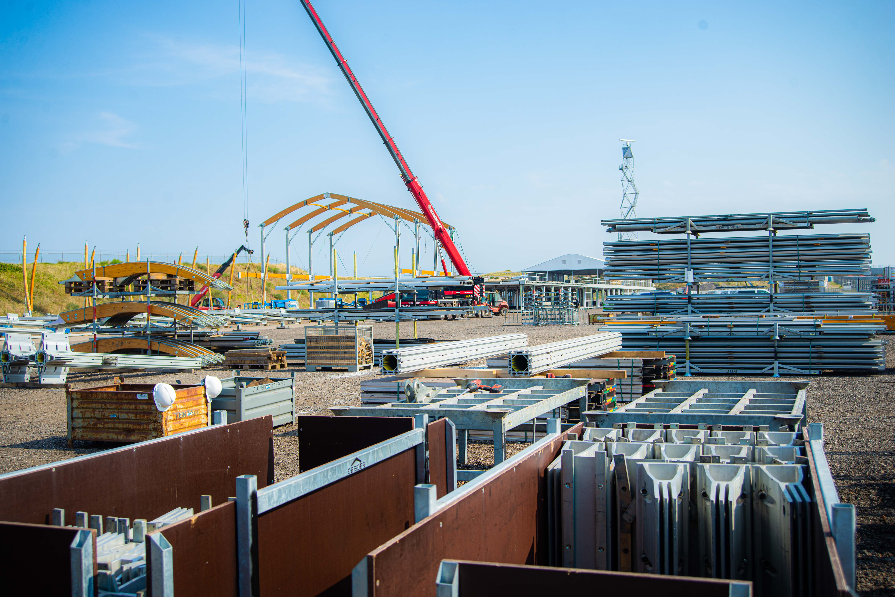

EFG TRAINING SERVICES PRIVATE LTD
Learning service PROVIDER by gic

No: 3 Soon Lee Street
# 01-16 Pioneer Junction
Singapore 627606

Ways to register
TEL: 6334-7872
FAX: 6334-7891
E-mail: admin@efg.com.sg
No: 3 Soon Lee Street
# 01-16 Pioneer Junction
Singapore 627606

Website:www.efg.com.sg

