OPERATE FORKLIFT (OFL with class 3) (GMS-LOG-1106-1.1-E)

Company Name: ________________________________________________________________________________

Contact Person: ____________________________________ H/P: ____________________________________

Tel: ________________ Fax: _________________ Email: ______________________________________________

Address: ______________________________________________________________________________________

No. | NRIC/FIN/WP No: | Full Name | Nationality | Preferred  Language | Preferred  Date
1.
2.
3.
4.
5.
Course Fees: $300/-per participant (Excluding 9% GST)
Total course fee: $___________Payment Mode: Cash Cheque Cheque No. ______________ (payable to EFG Training Services Private Ltd)
- The company reserves the right to revise the course fee without prior notice, to cancel or postpone the course due to unforeseen circumstances
- Replacement and Withdrawal
- 90% refund will be made if the notice of withdrawal in writing is received by EFG at one week before the course commencement date. If such notice is received by EFG less than one week but more than three working days before the course commencement date, 75% refund will be made. No refund will be given if EFG received the notice of withdrawal 3 working days before the course commencement date. Replacement of participant is allowed if the request is made before the commencement of the course
__________________ __________________________
Name: Signature/Date

Company Stamp
OPERATE FORKLIFT – WITH CLASS 3 LICENSE

Course Overview
This Competency Unit specifies the skills and knowledge required by people to operate in the trade pertaining to operate forklift in the manufacturing / logistics industry in a WSQ Level 1 operation.

Entry Requirement
Learners are assumed to
- Holding a valid LTA issued Class 3 driving licence in Singapore or Malaysia class D driving licence
- Above 18 years of age
- Safety shoes and proper attire (no singlet/ shorts/ Bermudas) are COMPULSORY for all

Target Audience
This course aims to provide people already working or wishing to enter the generic manufacturing industry with the skills and knowledge required to operate forklift. The Competency unit would be appropriate for people with job title such as Forklift driver.
Course Content
Types of forklifts and their load capacities
- Parts of forklift and their functions
- Workplace safety and health code of practice relating to forklift practice
- Protecting loads from damage during documentation
- Reporting procedures if work preparation is not completed
- Main parts of forklifts to be inspected
- Constituents of each main part of forklift to be inspected
- Safety precautions in inspecting forklift
- Cargo handling symbols
- Forklift stability
- Operating procedures for different types of loads
- Safety precautions in lifting potentially hazardous loads
- Operating procedures for different types of terrains and confined spaces
- Workplace safety and health code of practice relating to forklift operations
- Procedures of reporting unsafe/unauthorised forklift practices
- Procedures relating to parking of forklift
- Handover procedures of forklift

Course Duration
- 22 Hours including 2 hours Assessment

Medium of Instruction: English, Tamil, Bangladeshi, Mandarin

Teaching Methodology: Face to face classroom and practical teaching

Learning Environment: Our ergonomically designed classrooms are fully air-conditioned, equipped with
whiteboards; audio/video equipment and free wi-fi.

Class Size: Minimum 4 Maximum 20

Facilitator/Learner Ratio: 1:20 for Theory Lesson & Assessment | 1:1 for Practical Lesson & Assessment
(Group of 5 trainees to 1 Forklift/Trainer)

Course Attendance Minimum: 100% attendance

Assessment Advice: E-MCQ Assessment / Practical Performance

Funding & Claims

  - Skills future credit/funding available
SFC:
-All Singaporeans aged 25 and above can us their $500 Skill Future Credit from the government to pay for a wide range of approved skills-related courses. visit the Skills Future Credit website (www.skillsfuture.sg/credit) to choose from the courses available on the Training Exchange course directory
Mandatory adoption of e-attendance via Sing Pass from 1 October 2023: As per the SSG regulation we are introducing “e-attendance via Sing Pass,” for participants applying for funding. To ensure a smooth process, please verify your Sing Pass app access before attending the course. Kindly note that manual attendance submissions will not be accepted for funding invoices. Thank you for your cooperation.
Skills Future Singapore Hotline: For enquiries relating to skills, training and portal issues, please contact Skills Future Singapore at 6785 5785

Certifications
Based on the successful completion of the course and assessment, a card of achievement endorsed by EFG Training Services Private Ltd a Statement of Attainment (SOA) will be awarded by Skills Future Singapore Agency (SSG) will be awarded to the trainee. E-cert available. Card shall be endorsed by EFG Training Services Private Ltd and issued to participants at the end of course.

Course Fees
$300+GST

OPERATE FORKLIFT (OFL with class 3)

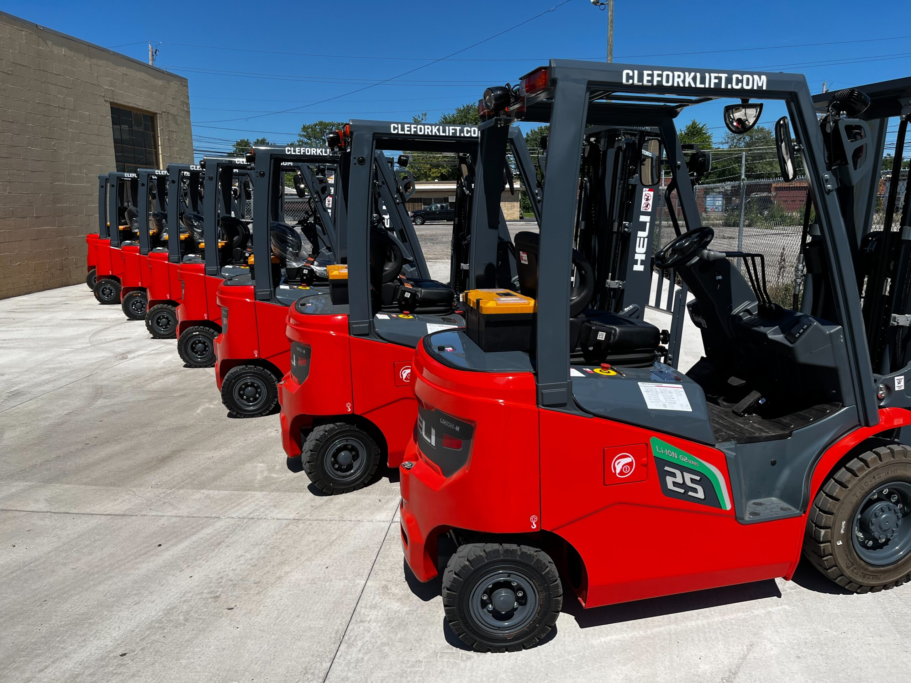

EFG TRAINING SERVICES PRIVATE LTD
Learning service PROVIDER by gic

No: 3 Soon Lee Street
# 01-16 Pioneer Junction
Singapore 627606

Ways to register
TEL: 6334-7872
FAX: 6334-7891
E-mail: admin@efg.com.sg
No: 3 Soon Lee Street
# 01-16 Pioneer Junction
Singapore 627606

Website:www.efg.com.sg

