OPERATE SCISSOR LIFT (GMS-COM-1106-1.1-E)
(English, Tamil, Bengali, Mandarin)

Company Name: ________________________________________________________________________________

Contact Person: ____________________________________ H/P: ____________________________________

Tel: ________________ Fax: _________________ Email: ______________________________________________

Address: ______________________________________________________________________________________
No. | NRIC/FIN/WP No: | Full Name | Nationality | Preferred  Language | Preferred  Date
1.
2.
3.
4.
5.
Course Fees: $250/-per participant (Excluding 9% GST)
Total course fee: $___________Payment Mode: Cash Cheque Cheque No. ______________ (payable to EFG Training Services Private Ltd)
- The company reserves the right to revise the course fee without prior notice, to cancel or postpone the course due to unforeseen circumstances
- Replacement and Withdrawal
- 90% refund will be made if the notice of withdrawal in writing is received by EFG at one week before the course commencement date. If such notice is received by EFG less than one week but more than three working days before the course commencement date, 75% refund will be made. No refund will be given if EFG received the notice of withdrawal 3 working days before the course commencement date. Replacement of participant is allowed if the request is made before the commencement of the course
__________________ __________________________
Name: Signature/Date

Company Stamp
OPERATE SCISSOR LIFT

Course Overview
The “Operate Scissor lift “Course is aimed at providing individuals with the knowledge and skills to operate scissor lifts safely. At the end of the course, participants will be proficient in selection of appropriate scissor lifts, conducting risk assessment and route checks, identification of hazards for scissor lift operations, basic scissor lift operations and reinstating scissors lift in a safe manner.

Entry Requirement
Learners must be above 18 years of age and are assumed to
- Have a basic knowledge of the relevant sector of work
- WPLN 3
- Be medically fit to work at height

Target Audience
The “Operate Scissor Lift” Course is suitable for aspiring and experienced individuals assigned as Scissor Lift Operators in the workplace.
Course Content
- Prepare to carry out Scissor lift operations
- Carry out Scissor lift operations
- Conduct post operation

Course Duration
- 9 Hours 15 Minutes including 1 Hour 15 Minutes of assessment

Medium of Instruction: English, Tamil, Bengali, Mandarin

Teaching Methodology: Face to face classroom and practical teaching

Learning Environment: Our ergonomically designed classrooms are fully air-conditioned, equipped with
whiteboards; audio/video equipment and free wi-fi.

Class Size: Maximum 5

Facilitator/Learner Ratio: 1:5 for Theory Lesson & Assessment

Course Attendance Minimum: 100% attendance

Assessment Advice: E-MCQ Assessment / Practical Performance

Funding & Claims

  - Skills future credit/funding available
SFC:
-All Singaporeans aged 25 and above can us their $500 Skill Future Credit from the government to pay for a wide range of approved skills-related courses. visit the Skills Future Credit website (www.skillsfuture.sg/credit) to choose from the courses available on the Training Exchange course directory
Mandatory adoption of e-attendance via Sing Pass from 1 October 2023: As per the SSG regulation we are introducing “e-attendance via Sing Pass,” for participants applying for funding. To ensure a smooth process, please verify your Sing Pass app access before attending the course. Kindly note that manual attendance submissions will not be accepted for funding invoices. Thank you for your cooperation.
Skills Future Singapore Hotline: For enquiries relating to skills, training and portal issues, please contact Skills Future Singapore at 6785 5785

Certifications
Based on the successful completion of the course and assessment, a card of achievement endorsed by EFG Training Services Private Ltd a Statement of Attainment (SOA) will be awarded by Skills Future Singapore Agency (SSG) will be awarded to the trainee. E-cert available

Course Fees
$250+GST

Course Venue Theory
No. 3 Soon Lee Street, #01-16, Pioneer Junction, Singapore 627606.

Course Venue Practical

No. 1 Soon Lee Street, Pioneer Centre #01-33, Singapore 627605
No. 3 Soon Lee Street, #01-16, Pioneer Junction, Singapore 627606.

OPERATE SCISSOR LIFT

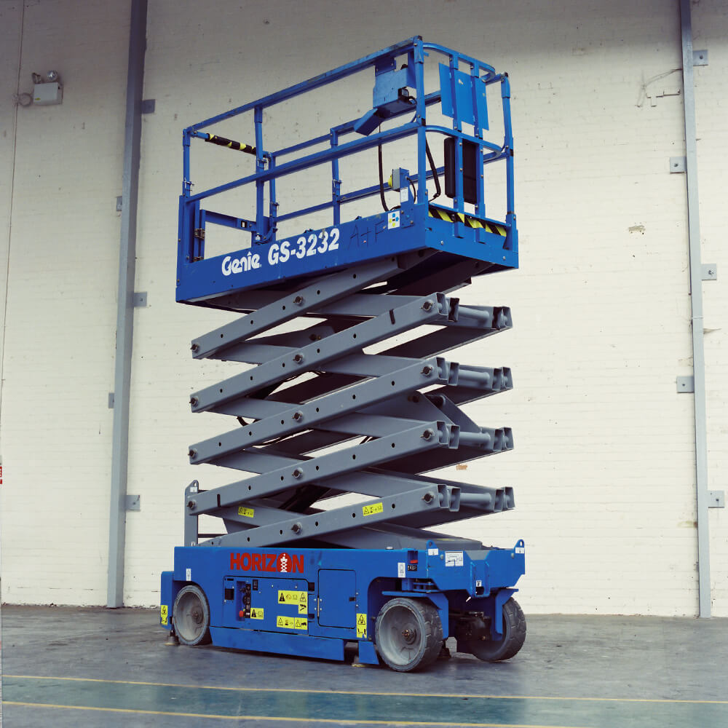

EFG TRAINING SERVICES PRIVATE LTD
Learning service PROVIDER by gic

No: 3 Soon Lee Street
# 01-16 Pioneer Junction
Singapore 627606

Ways to register
TEL: 6334-7872
FAX: 6334-7891
E-mail: admin@efg.com.sg
No: 3 Soon Lee Street
# 01-16 Pioneer Junction
Singapore 627606

Website:www.efg.com.sg

