TUNNELING (SOC)

(English, Tamil, Malay, Mandarin, Bengali, Thai, Hindi and Burmese)

Company Name: ________________________________________________________________________________

Contact Person: ____________________________________ H/P: ____________________________________

Tel: ________________ Fax: _________________ Email: ______________________________________________

Address: ______________________________________________________________________________________

No. | NRIC/FIN/WP No: | Full Name | Nationality | Mobile No. | Email ID
1.
2.
3.
4.
5.
6.
7.
8.
9.
10.

Course Fees: $50/-per participant (Excluding 9% GST)
Total course fee: $___________Payment Mode: Cash Cheque Cheque No. ______________ (payable to EFG Training Services Private Ltd)
- The company reserves the right to revise the course fee without prior notice, to cancel or postpone the course due to unforeseen circumstances
- Replacement and Withdrawal
- 90% refund will be made if the notice of withdrawal in writing is received by EFG at one week before the course commencement date. If such notice is received by EFG less than one week but more than three working days before the course commencement date, 75% refund will be made. No refund will be given if EFG received the notice of withdrawal 3 working days before the course commencement date. Replacement of participant is allowed if the request is made before the commencement of the course
__________________ __________________________
Name: Signature/Date
Company Stamp

Course Overview
This course is intended for all workers carrying out tunneling works in building and engineering construction worksites. The course will familiarize participants with the hazards associated when working in a tunnel. They will then be able to identify the hazards, know the preventive measures to be adopted and understand the importance of observing safety signs and safe work procedures.

Who should attend this course?
All workers required to carry out tunneling works in their daily operations and activities exposing themselves to hazards arising from tunnels.

Course Objectives
This course is aimed at providing individuals with the requisite Tunneling knowledge and skills so as to perform their Tunneling activities properly and safely. At the end of the course, participants will be able to:
  - Understand general safety in Tunneling Works
  - Identify and eliminate hazards working in a Tunnel
  - Practice safety procedures when operating Tunneling Equipment and Machinery
  - Able to work safely in Confined Spaces
  - Practice safety procedure when doing Hot Work and working in Compressed Air
  - Competent in wearing Personal Protective Equipment (PPE)
  - Know the dangers and precautionary measures associated with Tunneling Works

Pre-Requisites / Assume Skills and Knowledge
As a prerequisite to the course, learners must complete and passed the Apply Workplace Safety and Health in Construction Sites previously known as Construction Safety Orientation Course for Workers.

Trainer to Trainee Ratio
Theory / Assessment; 1: 40

Course Duration
4.0 Hours (Including 15 min e-Assessment)

Attendance requirements
100%

Assessment
Comprising Theory Session
Online MCQ

Medium of Instruction
English, Tamil, Malay, Mandarin, Bengali, Thai, Hindi and Burmese

Training Methodology
Slides presentation, sharing of best practice and incident. Short Videos.

Passing marks
Examination: 60%

Certifications
Certificates Cards shall be endorsed by EFG Training Services Private Ltd and issued to participants at the end of course.

Course Fees
$50/-

TUNNELING (SOC)

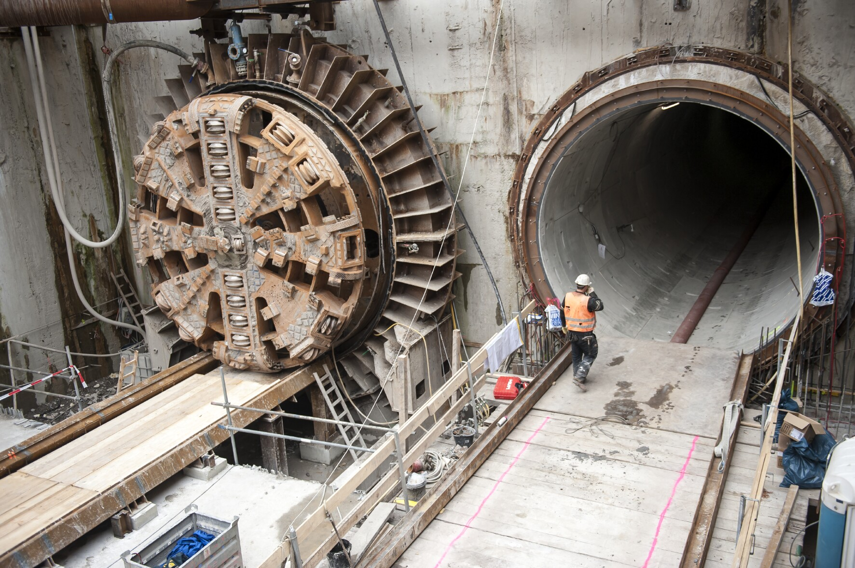

EFG TRAINING SERVICES PRIVATE LTD
Learning service PROVIDER by gic

No: 3 Soon Lee Street
# 01-16 Pioneer Junction
Singapore 627606

Ways to register
TEL: 6334-7872
FAX: 6334-7891
E-mail: admin@efg.com.sg
No: 3 Soon Lee Street
# 01-16 Pioneer Junction
Singapore 627606

Website:www.efg.com.sg

