CONFINED SPACE RESCUE COURSE

Company Name: ________________________________________________________________________________

Contact Person: ____________________________________ H/P: ____________________________________

Tel: ________________ Fax: _________________ Email: ______________________________________________

Address: ______________________________________________________________________________________

No. | NRIC/FIN/WP No: | Full Name | Nationality | MobileNo | Email ID
1.
2.
3.
4.
5.
Course Fees: $350/-per participant (Excluding 9% GST)
Total course fee: $___________Payment Mode: Cash Cheque Cheque No. ______________ (payable to EFG Training Services Private Ltd)

- The company reserves the right to revise the course fee without prior notice, to cancel or postpone the course due to unforeseen circumstances
- Replacement and Withdrawal
- 90% refund will be made if the notice of withdrawal in writing is received by EFG at one week before the course commencement date. If such notice is received by EFG less than one week but more than three working days before the course commencement date, 75% refund will be made. No refund will be given if EFG received the notice of withdrawal 3 working days before the course commencement date. Replacement of participant is allowed if the request is made before the commencement of the course
__________________ __________________________
Name: Signature/Date

Company Stamp

CONFINED SPACE RESCUE COURSE

Course Overview

This course has been designed to meet the minimum standard for Confined Space Rescue, as recommended in the WSH (Confined Space) Regulations 2009, SS 568 : 2011, Technical Advisory on Working Safely in Confined Spaces and Confined Space Safety Guidebook for Supervisors and Workers.

Who should attend this course?

The course is for anyone involved in the supervision, planning / assessment or management of confined space work activities.

Course Objectives/Contents
The aim of the course is to provide Learners with the requisite skills, knowledge to manage and rescue, so that work can be carried out safely. At the end of the course, the Learner shall be able to:

- Identify, explain and apply the relevant Workplace Safety and Health (WSH) Legislations / Approved Code of Practice / Singapore Standards applicable to Confined Space
- Identify and explain the Roles & Responsibilities of stakeholders, competent and responsible persons.
- Identify hazards, evaluate the risk, and implement control measures for Confined Space Work activities
- Review the necessary fall preventive / protective control measures for safe execution of Confined Space Work activities
- Establish, evaluate, review and implement a Confined Space Rescue Plan
- Establish and implement a system for an effective rescue and control of Confined Space Work risks
- Demonstrate competency in donning, checking and correcting of Confined Space Rescue Equipment and Responding to a confined space emergency and Perform Confined Space Rescue.

Pre-Requisites / Assume Skills and Knowledge

The Learner should have at least WSQ ESS Workplace Literacy and Numeracy Level 4 and above or equivalent and the ability to carry out hazards identification, risk assessment, and risk control measures.

Trainer to Trainee Ratio
1: 20 Theory & 1: 20 Theory Assessment
1: 10 Practical & 1: 1 Practical Assessment

Course Duration
7 Hours (Including 2.5 hours Assessment)

Attendance requirements
100%

Assessment
Comprising both Theory and Practical Session
Written Test (WT) / Practical Performance (PP)

Medium of Instruction
English

Training Methodology
Slides presentation, sharing of best practice and incident. Hands on practical session.

Passing marks
Theory Examination (WT): 70%
Practical Assessments (PP): 100%

Certifications
Certificates and Cards shall be endorsed by EFG Training Services Private Ltd and issued to participants at the end of course.

Course Fees
$350+GST

CONFINED SPACE RESCUE COURSE

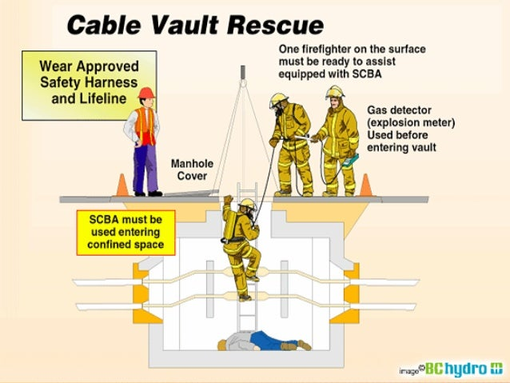

EFG TRAINING SERVICES PRIVATE LTD
Learning service PROVIDER by gic

No: 3 Soon Lee Street
# 01-16 Pioneer Junction
Singapore 627606

Ways to register
TEL: 6334-7872
FAX: 6334-7891
E-mail: admin@efg.com.sg
No: 3 Soon Lee Street
# 01-16 Pioneer Junction
Singapore 627606

Website:www.efg.com.sg

