Personal Fall Protection Equipment Inspector – PFPEI (English)

Company Name: ________________________________________________________________________________

Contact Person: ____________________________________ H/P: ____________________________________

Tel: ________________ Fax: _________________ Email: ______________________________________________

Address: ______________________________________________________________________________________

No. | NRIC/FIN/WP No: | Full Name | Nationality | Mobile No. | Email ID
1.
2.
3.
4.
5.
6.
7.
8.
9.
10.
Course Fees: $250/-per participant (Excluding 9% GST)
Total course fee: $___________Payment Mode: Cash Cheque No. ______________ (payable to EFG Training Services Private Ltd)

Terms and conditions

- Personal information details collected is for the use ONLY for course registration, account servicing of course-related activities, course survey and / or for application of course-related funding (only if applicable)
- Course surveys shall be conducted by SSG for selected courses thru the trainees emails or contact given
- Registration forms shall be submitted 7 days before the course commencement date
- The company reserves the right to revise the course fee without prior notice, to cancel or postpone the course due to unforeseen circumstances
- Replacement and Withdrawal
90% refund will be made if the notice of withdrawal in writing is received by EFG 6-4 days before the course commencement date. No refund will be given if EFG received the notice of withdrawal 3 working days before the course commencement date. Replacement of participant is allowed if the request is made before the commencement of the course

__________________ __________________________
Name: Signature/Date

Company Stamp
For Whom
All personnel interested in additional experience inspecting personal fall protection equipment. The typical participant is responsible for the care, marking and maintenance of equipment.
Entry Requirement
- Workplace literacy and numeracy Level 4 under Employability Skills System (ESS) or equivalent.
- Work at height course for Supervisors.
Course Overview
The aim of the course is to provide course participants with the requisite knowledge on the work at height, capability to conduct pre-use and annual fall protection equipment inspection, knowledge on equipment maintenance, storage and servicing.
Course Content
- Introduction to Work-at-Height.
- Work At Height Legislations.
- Introduction to different PPE.
- Regulations specific to the Inspection of PPE.
- Common wear and tear, lifespan and expiry dates of PPE.
Course Duration: 4 hours
Medium of Instruction: English
Class Size: Maximum 20
Facilitator/Learner Ratio:
1:20 for Theory Lesson
Course Attendance: 100% attendance.
Assessment Advice
Create Inspection Checklist

Personal Fall Protection Equipment Inspector - PFPEI

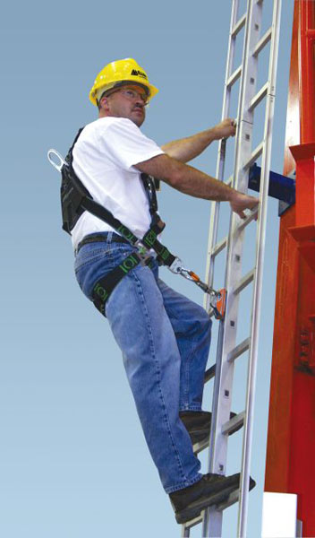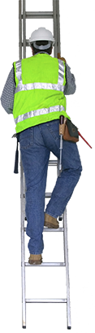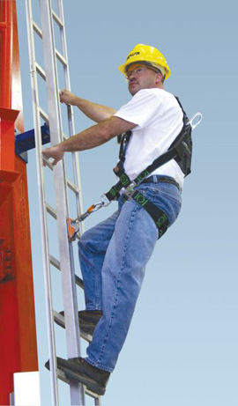

EFG TRAINING SERVICES PRIVATE LTD
ACREDITED TRAINING PROVIDER

No: 3 Soon Lee Street
# 01-16 Pioneer Junction
Singapore 627606

Ways to register
TEL: 6334-7872
FAX: 6334-7891
E-mail: admin@efg.com.sg
No: 3 Soon Lee Street
# 01-16 Pioneer Junction
Singapore 627606

Website: www.efg.com.sg

